Name: T.Vamsi Krishna
Roll no : 2503A52705
Lab: 12

Task 1: Linear Search
Question:
Task Description #1: Linear Search
Implementation with AI Assistance
Task: Use an AI tool to generate a Python program that implements the Linear Search
algorithm.
Instructions:
Prompt AI to create a function linear_search(arr, target) that searches
for a target element in a list.
Return the index of the target element if found; otherwise, return -1.
Ask AI to include a docstring explaining the best-case, average-case, and
worst-case time complexities.
Test the function with different inputs, including an empty list and a target that
is not present.
Expected Output:
A working Python program implementing Linear Search.
Test cases with outputs.
A brief explanation of time complexity.
Prompt:
Write linear_search(arr, target) in Python. Return the index or -1, add a docstring with best/average/worst time complexity, and test normal, empty, and missing-target cases.
Code:
def linear_search(arr, target):
"""Best: O(1); Average: O(n); Worst: O(n)."""
for i, value in enumerate(arr):
if value == target:
return i
return -1
numbers = [10, 25, 30, 45, 50]
print("Target 30:", linear_search(numbers, 30))
print("Target 10:", linear_search(numbers, 10))
print("Target 99:", linear_search(numbers, 99))
print("Empty list:", linear_search([], 10))
Output:

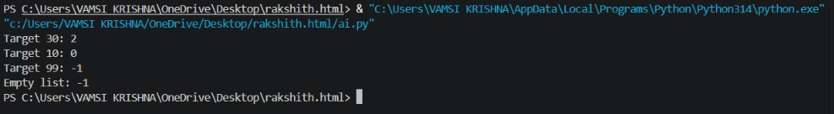

Explanation:
Linear Search checks items one by one. Best case is O(1); average and worst cases are O(n).
Task 2: Binary Search
Question
Implement iterative Binary Search on a sorted list. Test first, middle, last, and missing values.
Prompt
Write iterative binary_search(arr, target) for a sorted list. Return the index or -1, document time complexity, and test first, middle, last, and missing targets.
Python Code
def binary_search(arr, target):
"""Best: O(1); Average: O(log n); Worst: O(log n).
The list must be sorted in ascending order.
"""
low, high = 0, len(arr) - 1
while low <= high:
mid = (low + high) // 2
if arr[mid] == target:
return mid
if arr[mid] < target:
low = mid + 1
else:
high = mid - 1
return -1
numbers = [10, 20, 30, 40, 50, 60, 70]
for target in [10, 40, 70, 45]:
print(target, "->", binary_search(numbers, target))
Output

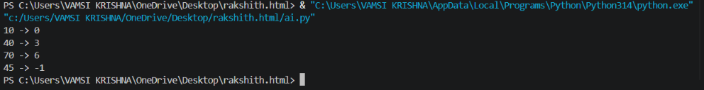

Explanation
Binary Search needs sorted data because it discards half of the search range each step. It runs in O(log n) average and worst-case time.
Task 3: Student Record Search System

Question
Search student records by roll number using Linear Search and Binary Search. Compare results for unsorted and sorted records.

Prompt
Create student records with roll number, name, and marks. Implement Linear and Binary Search by roll number, test unsorted and sorted records, and explain their time complexity.

Python Code
def linear_search(records, roll_no):
for i, student in enumerate(records):
if student["roll_no"] == roll_no:
return i
return -1
def binary_search(records, roll_no):
low, high = 0, len(records) - 1
while low <= high:
mid = (low + high) // 2
value = records[mid]["roll_no"]
if value == roll_no:
return mid
if value < roll_no:
low = mid + 1
else:
high = mid - 1
return -1
students = [
{"roll_no": 103, "name": "Kiran", "marks": 82},
{"roll_no": 101, "name": "Anu", "marks": 91},
{"roll_no": 105, "name": "Ravi", "marks": 76},
{"roll_no": 102, "name": "Meena", "marks": 88},
]
print("Unsorted Linear Search:", linear_search(students, 102))
sorted_students = sorted(students, key=lambda s: s["roll_no"])
print("Sorted Binary Search:", binary_search(sorted_students, 102))
print("Record:", sorted_students[binary_search(sorted_students, 102)])

Output

Explanation
Linear Search works on sorted or unsorted records in O(n) average/worst time. Binary Search needs sorted records and takes O(log n) average/worst time. For frequently searched sorted records, Binary Search is preferable.

Task 4: Library Book Search System

Question
Search existing and missing book IDs using Linear and Binary Search. Count and compare the number of comparisons.

Prompt
Write Linear and Binary Search functions that return the index and comparison count. Test an existing and missing book ID, sorting the list for Binary Search.

Python Code
def linear_search_count(arr, target):
comparisons = 0
for i, value in enumerate(arr):
comparisons += 1
if value == target:
return i, comparisons
return -1, comparisons
def binary_search_count(arr, target):
low, high = 0, len(arr) - 1
comparisons = 0
while low <= high:
mid = (low + high) // 2
comparisons += 1
if arr[mid] == target:
return mid, comparisons
if arr[mid] < target:
low = mid + 1
else:
high = mid - 1
return -1, comparisons
books = [410, 125, 305, 220, 515, 180, 460]
sorted_books = sorted(books)
for target in [305, 999]:
print("Book ID:", target)
print("Linear:", linear_search_count(books, target))
print("Binary:", binary_search_count(sorted_books, target))

Output

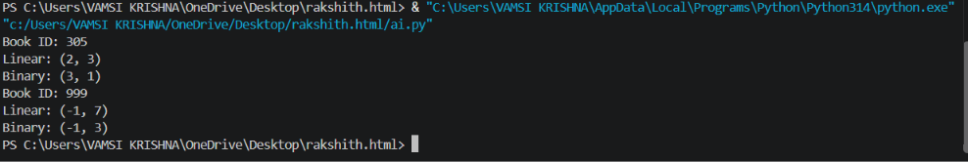

Explanation
Linear Search does not require sorting but may check every ID. Binary Search is more efficient for a large sorted collection because it runs in O(log n), compared with O(n) for Linear Search.

Task 5: Searching Algorithm Comparison and Optimization

Question
Compare Linear and Binary Search for product IDs of different sizes using execution time and comparison counts. Test first, middle, last, and missing targets.

Prompt
Write Linear and Binary Search functions that count comparisons. Test sorted product ID lists of sizes 100, 1000, and 10000 for first, middle, last, and missing targets. Measure execution time and print a comparison table.

Python Code
from time import perf_counter
def linear_search(arr, target):
count = 0
for i, value in enumerate(arr):
count += 1
if value == target:
return i, count
return -1, count
def binary_search(arr, target):
low, high, count = 0, len(arr) - 1, 0
while low <= high:
mid = (low + high) // 2
count += 1
if arr[mid] == target:
return mid, count
if arr[mid] < target:
low = mid + 1
else:
high = mid - 1
return -1, count
print("N Case Algorithm Index Comparisons Time(ms)")
for n in [100, 1000, 10000]:
products = list(range(n))
tests = [("first", products[0]), ("middle", products[n//2]),
("last", products[-1]), ("missing", -1)]
for case, target in tests:
for name, func in [("Linear", linear_search), ("Binary", binary_search)]:
start = perf_counter()
index, count = func(products, target)
elapsed = (perf_counter() - start) * 1000
print(n, case, name, index, count, f"{elapsed:.6f}")

Output

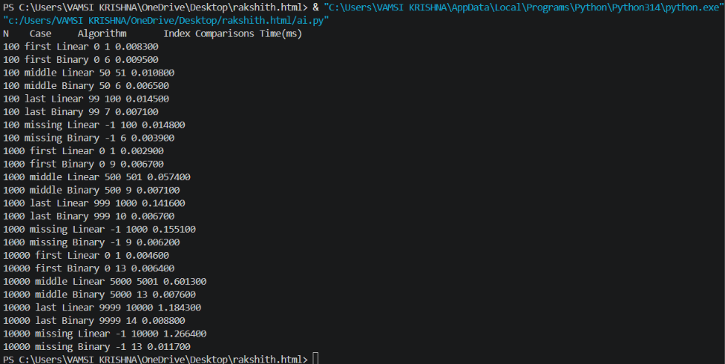

Explanation
Linear Search has O(n) average/worst time and works on unsorted data. Binary Search has O(log n) average/worst time but requires sorted data. Timings vary by computer; comparison counts are more consistent.

